Helpful information When Programming in R
- R is case sensitive. If you name a variable (object) Grades, then you must refer to it as Grades, not grades, GRADES, etc.
- The up and down arrow keys can be used to recall and scroll through past commands, which can save typing when fixing typos or modifying a command.
- Entering a letter and then hitting the Tab key twice will list the commands and objects starting with that letter
Helpful information When Programming in R
- Material can be cut and pasted into or from the R window. This allows you to save and print R results as part of MS Word documents or save the text of your R session as a record of your work. R text is generally formatted as Courier font and using Courier, 9 point font, works well for R output.
- There is a lot of R help found on the internet. For example, if you were stuck trying to decipher the R help page for and ANOVA problem, google 'Analysis of Variance R’. You will find sites offering examples and/or helps.
- As with any software program, there usually is more than one way to do things using R. The methods in this class are not the only way to perform the analyses through R, and you should feel free to experiment and explore.
Assign Operator and Inputting a DATA Vector
- To make a comment in R (not part of code) begin the line with “#”
- The assign operator, “<-” is used to assign a name to an object (variable). “c()” is a function creating a column vector with the indicated values.
- #Below is the code to assign and give values to a specific object/variable named heights_of_shrubs
- > heights_of_shrubs<-c(12.3,12.6,12.9,11.9,12.0)
- In R, these values are represented as a column vector (as a data set, these values would be arranged in one column for the variable heights_of_shrubs, with 5 rows).
- “>” is the ready prompt in R, indicating that R is ready for our input (R typed the >, you must type in the rest. I will use the color blue to indicate what you must type.
- #Below is the code to print the specific object/variable named heights_of_shrubs
- > heights_of_shrubs
- Results will look like this: [1] 12.3 12.6 12.9 11.9 12.0
- >
- The '[1]' the R gives at the start of the line is a counter – this line starts with the first value in the object (this is helpful with larger data sets when the print out extends over several lines).
- We can use this object name in later analyses. For example, the mean heights of these 5 shrubs can be calculated using the “mean()”function:
- Below is the code to calculate the mean of the specific object/variable named heights_of_shrubs
- > mean(heights_of_shrubs)
- Results will look like: [1] 12.34
- >
Importing DATA files into R using code
- You can use code to import a DATA file, or you can use the drop-down feature in R Studio
- We will first look at the code used to import an EXCEL .csv file using the correct file pathway. Once you save a file, you can find the correct pathway by right clicking on file. A dropdown box will appear. Go down to properties, and you will see the pathway next to Location. Here is the code for a CSV file that has the variable names in the 1st row:
- #Below is the code to import the EXCEL .csv file called imdb.csv
- > imdb <- read.csv(“C:/Users/UMD/imdb.csv", header=TRUE)
- It will appear in the Environment tab in Rstudio
- To view it: #Below is the code to view the EXCEL .csv file called imdb.csv
- > View(imdb)

Importing DATA files using Drop-Down Feature in R
- To You can use code to import a DATA file other than an R file you can use the drop-down feature in R Studio. Once you click on the file type a box will appear where you can choose a file on your computer.
- 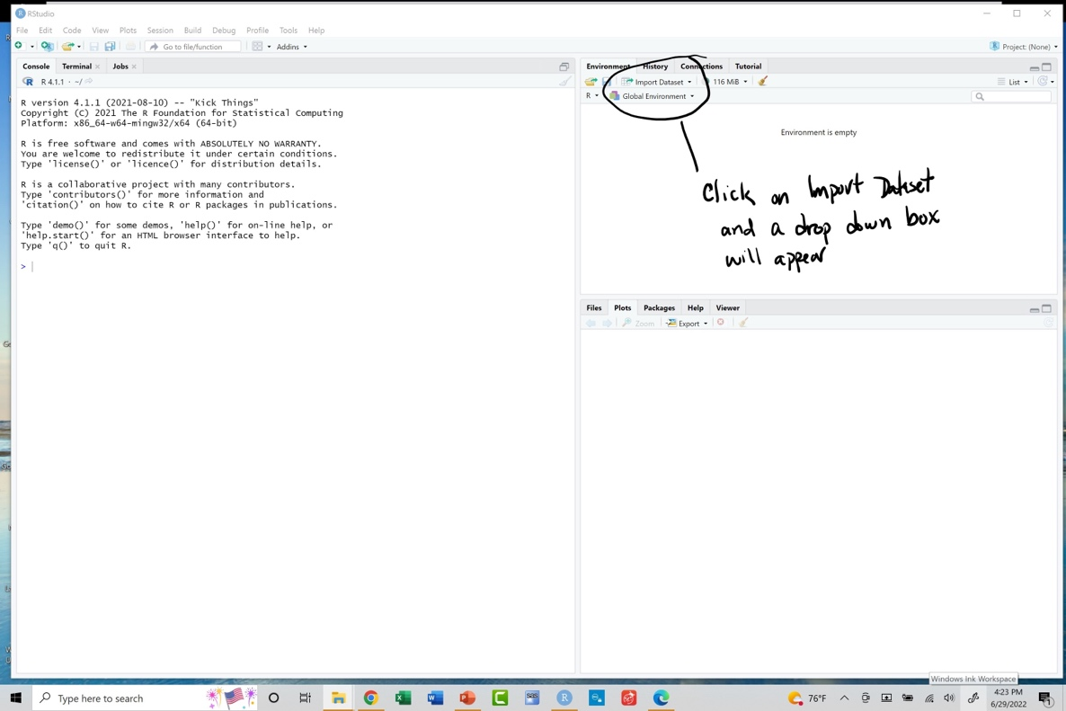
- 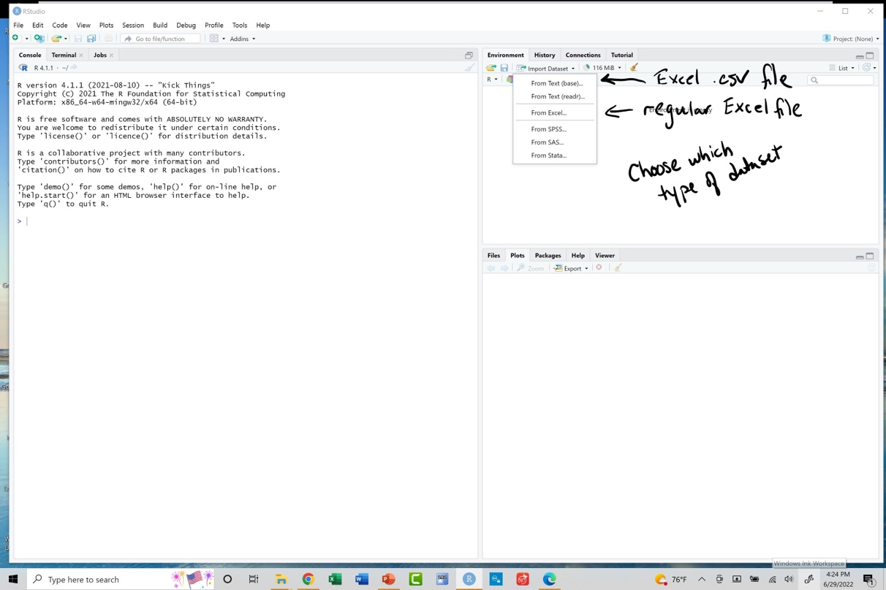
- One you choose a file another box will appear. You must determine if the file has the variable name as the first row or not. The .csv file imdb does have the variable names as the first row, so I will click yes for Heading.
- Then click Import.
- 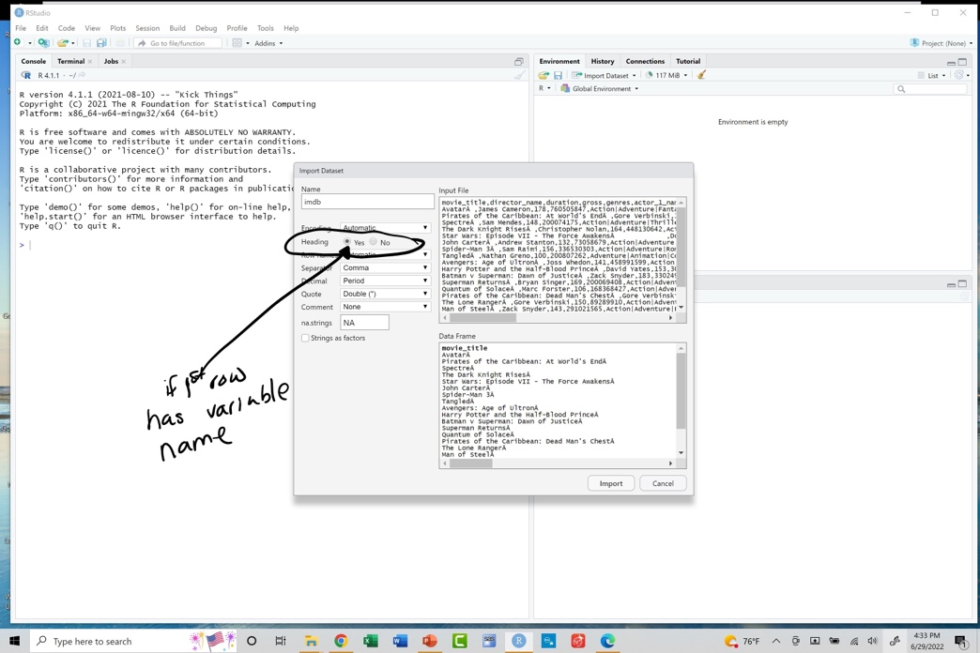
- 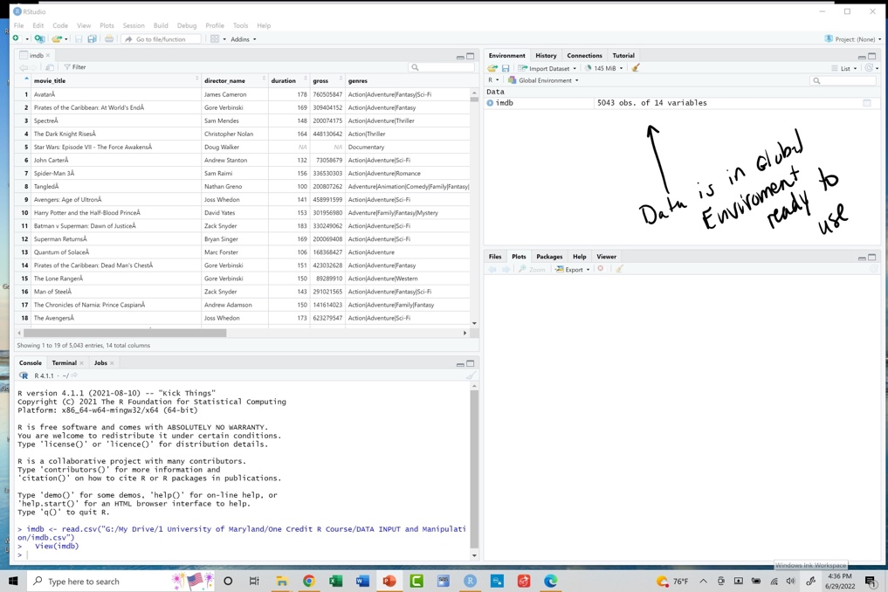
Default Working Directory in R
- A default working directory is a folder where Rstudio goes, everytime you open it. You can change the default working directory from Rstudio menu under “Tools”
- A dropdown box will appear, choose “Global options”
- A new dropdown box will appear, choose “Browse”
- Select the default working directory you want
- Then you can always load your data files here
Stimulating DATA
- You can generate data from various distributions
- To print an object, use the code is below in the box to generate simulated data for a shrub that has a mean height of 13 inches and a standard deviation of 1.3 inches :
- #Below is the code to simulate 100 data values for the scrub above and store in vector called shrub13
- > shrub13<-rnorm(100, mean = 13, sd = 1.3)
- Vector shrub13 will appear in Global Environment and is ready to use
- Some common distributions to stimulate
Distribution | Command
Normal | rnorm(n, mean = vaule, sd = value)
Students | Rt(n, df)
F Distributions | Rf(n, df1, dr2)
Chi Square Distributions | Rchisa(n, df)
Sample from a DATA set
- You can generate a sample from a data set
- >#Creating the dataset
- > data_set<-c(1,3,5,7,9,11,13,15,17,19,21,23,25,27,29,31)
- > #We want to make 2 random samples of size 5 without replacement
- > sample1<-sample(data_set,5,replace=FALSE)
- >sample2<-sample(data_set,5,replace=FALSE)
- >#To see the samples
- >sample1
- [1] 23 9 13 7 29
- >sample2
- [1] 7 25 29 11 3
Editing and Saving a DATA set
Upload your dataset and use edit command to edit the data
- >#After uploading the data set Student_Grades, I use edit to begin to edit and save
- >New_Student<-edit(Student_Grades)
- >#A window will appear where you can change values and adjust variable type, click file>close
- >#Code to save the file to your working directory as a csv file
- >write.csv(New_Student, file= "000Student.csv")
- >#You will not see anything, but the file has been saved to your working directory
- Where can you easily find your working directory, go to the lower right panel in R, click on files, and your working directory will appear
Upload your dataset and use subset to create a new file with a variable you would like
- >#After uploading the data set Student_Grades, I would like to create a new file with just MT 1,MT2, >#and MT3 grades. The name my new file and use the subset command to get these variable
- >tempdf<-subset(New_Student,select = c(MT1,MT2,MT3))
- >#Code to save the file to your working directory as a csv file
- >write.csv(tempdf2, file= "000_StudentMTs.csv")
- >#You will not see anything, but the file has been saved to your working directory
Upload your dataset and use subset to create a new file with the variables you would like deleted
- >#After uploading the data set Student_Grades, I would like to create a new file without MT1
- >Name my new file and use the subset command to get these variable
- >tempdf3<-subset(New_Student,select = -MT1)
- >#Code to save the file to your working directory as a csv file
- >write.csv(tempdf3, file= "000_Student_no_MT1.csv")
- >#You will not see anything, but the file has been saved to your working directory
Upload your dataset and use subset to create a new file with the variables you would like to delete
- >#After uploading the data set Student_Grades, I would like to create a new file with just MT 1,MT2, >#and MT3 grades deleted. Name my new file and use the subset command to get these variable
- >tempdf4<-subset(New_Student,select = -c(MT1,MT2,MT3))
- >#Code to save the file to your working directory as a csv file
- >write.csv(tempdf4, file= "000_Student_no_MTs.csv")
- >#You will not see anything, but the file has been saved to your working directory
- Where can you easily find your working directory, go to the lower right panel in R, click on Files, and your working directory will appear

